ST 352

**Lab Assignment 6 - SOLUTIONS**

***14 points***

***Due 11:59 PM on Friday, November 22***

**Reminder of the honor code:**

**lab assignments are to be completed individually!**

**Number your answers. Put the questions in order! Once completed, upload your assignment in Gradescope. After uploading your assignment in Gradescope, remember to link each question to the page on which that question appears in your document. (One-point deduction if you do not link questions to a page.)**

The questions on this assignment pertain to the **paint** example from the Lab 6 Notes:

Researchers wanted to compare the “reflectivity” of four different paints used on highways. Twenty-four sections of highways were randomly selected and one of four types of paints (P1, P2, P3, or P4) was randomly assigned to each section of highway so that each type of paint was used on six sections. After six months, the percent of the original reflectivity was determined and recorded for each paint. The data are in the **paint** data set. The variables are:

* ***reflectivity*** (percent of original reflectivity after 6 months)
* ***type*** (type of paint)

To start, we want to determine if *at least* one type of paint has a different mean percent reflectivity.

1. ***(2 points)***State the null and alternative hypotheses *in words.*

**H0: All four types of paint have the same mean percent of original reflectivity after 6 months**

**HA: At least one type of paint has a different mean percent of original reflectivity after 6 months**

**Deductions:**

**-1 for having hypotheses reversed**

**-1/2 if do not have “at least one” in alternative hypothesis**

**-2 if not in words**

**-1.5 if use “explanatory variables” instead of “means”**

**Other deductions at your discretion**

2. ***(1 point)***In the Lab 6 Notes, you obtained side-by-side box-and-whisker plots. Include the properly-labeled side-by-side box-and-whisker plots here.

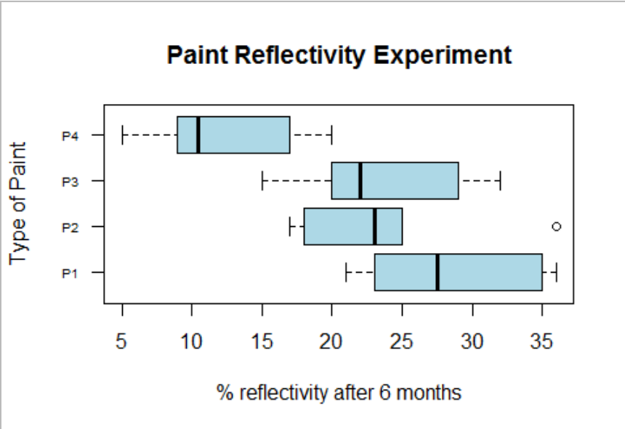

3. ***(2 points)***From the side-by-side box-and-whisker plots, do you believe the null hypothesis stated in question 1 will be rejected? Briefly explain. (Only use the side-by-side box-and-whisker plots in your explanation.)

***This is subjective – grade based on support. Paint P4 looks like it has a lower mean than the other three types of paint (which have similar means), and there is not overlap of the P4 box with the boxes of the other three types of paint, which could support that the null hypothesis will be rejected. But, again, whether a student thinks this is “significant” is subjective.***

**2 points for support (partial credit can be given)**

4. ***(2 points)***To use the Analysis of Variance procedure, the spread in each population must be the same. Using the side-by-side box-and-whisker plots only, do you feel the spread in *reflectivity* is the same for all four paints? Explain, including the feature of the side-by-side box-and-whisker plots that is used to assess the “constant variation condition”(i.e. same spread in each population).

***The spread appears to be similar since the width of the boxes is similar and the length of the whiskers is similar. But, answers can vary as even though the spreads look similar, paint P1 appear to have a larger IQR than paint P2. This is even more subjective than question 3. Look for support (which should only be from the box-and-whisker plots).***

* **If student does not use side-by-side box-and-whisker plots to support their answer, the maximum points that can be given is 0.5.**
* **If student does not specify what feature of the side-by-side box-an-whisker plots they are using (i.e. width of boxes and/or lengths of whiskers (both don’t have to be referenced!)), maximum that can be given is 1 point**

5. ***(2 points)***Report the appropriate test-statistic with degrees of freedom and the p-value to test the null hypothesis in question 1. (Remember, a “test-statistic” can be a t-statistic or an F-statistic. Report the correct one that is used to answer this question of interest.)

f-stat = 7.43 (1/2 point for the correct value, ½ point for stating it’s an “f-stat”)

degrees of freedom is 3 and 20 (1/2 point: ¼ point for each)

p-value = 0.0016 (1/2 point – should be reported exactly as it appears in output. If report p-value as < 0.01, take off ¼ point. Do not give credit for “p-value < 0.05”.)

6. ***(3 points)***From the p-value reported in question 5, state a conclusion in a complete sentence in the context of the problem.

There is strong evidence to suggest the mean percent of original reflectivity is different for at least one of the paint types.

7. ***(2 points)***Regardless of your conclusion in question 6, use the results of the Bonferroni multiple comparison to determine which group or groups have different means. Report the group or groups with different means and the p-values you are using to make this conclusion.

**Here are the p-values using the p.adjust.method = “bonf”. (If student used “none”, each p-value below would be divided by 6) for those that are “significant”. (Other p-values are not given and do not need to be reported.)**

P4 vs P1 – p-value = 0.0012

P4 vs P2 – p-value = 0.025

P4 vs P3 – p-value = 0.03

**Paint 4 seems to have a different mean than the others since it was the type of paint that was involved in all t-test that resulted in “significant” differences in means.**

**+1 for reporting p-values**

**+1 for stating P4 is the type of paint with a different mean**

**+1 for proper support for stating that P4 is the type of paint with a different mean**